Exercises 1.1.2

1. How is the cloud used in Windows 10 to improve your Windows experience?

The customized settings saved with your account apear automatically on the new device

1. Which are the most important parts of the Windows UI (User Interface)?

-Start button

-Takbar

-Notification área

-Search box

1. Which are the 3 segments of the “Start” menu?

-The current user’s name and picture

-Icons for File Explorer

-Settings and Power

1. Change the settings of your Taskbar and see the effects of those changes.

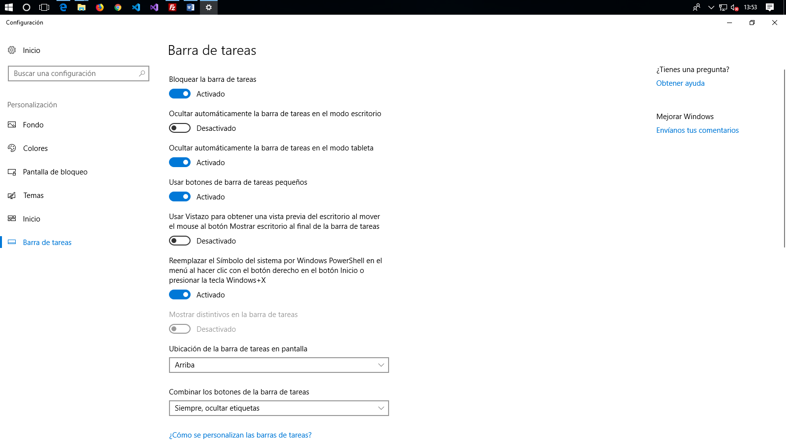

1. Switch between programs using the Task View.

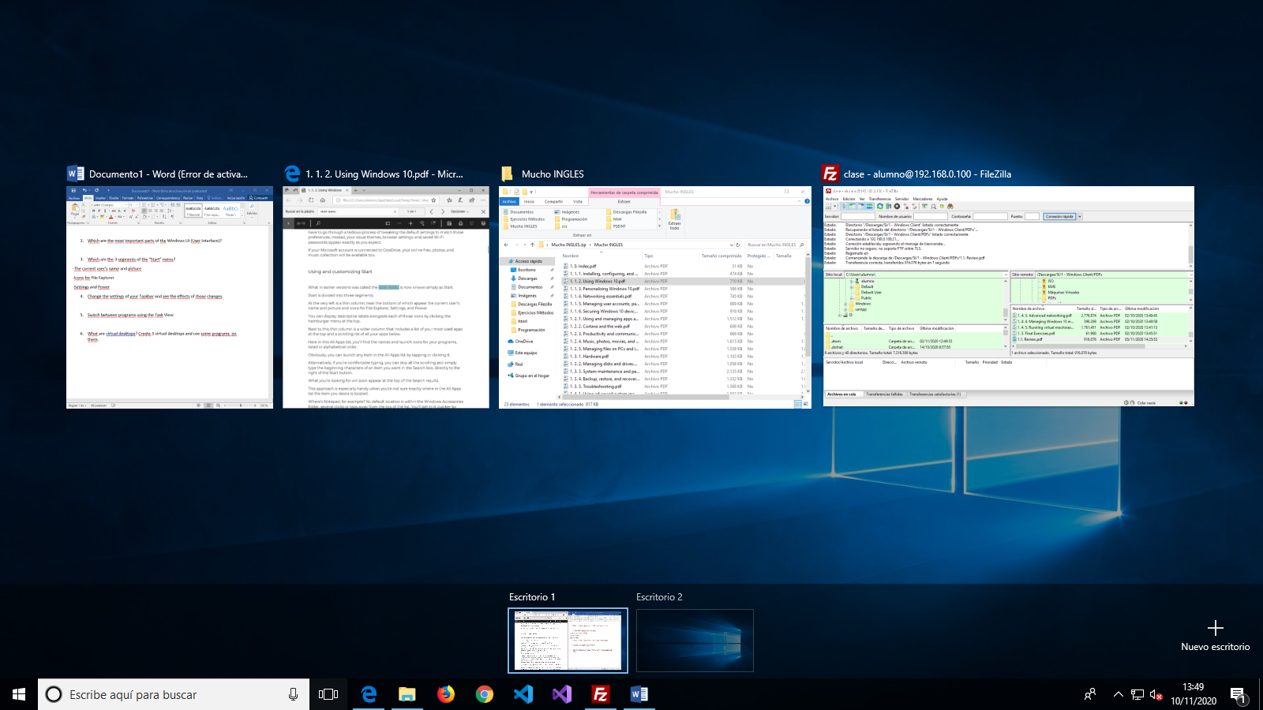

1. What are virtual desktops? Create 3 virtual desktops and use some programs  on them.

